Open call for best practice case studies: Teaching & Learning in the time of COVID
June 2021

Introduction to TASO
The Centre for Transforming Access and Student Outcomes in Higher Education (TASO) aims to improve lives through evidence-based practice in higher education (HE). Our vision is to eliminate equality gaps for disadvantaged and underrepresented groups, allowing all students to have the same chance to enter HE, get a good degree and progress into further study or employment. TASO was set up in 2019, by a consortium of King’s College London, Nottingham Trent University and the Behavioural Insights Team.
We are an independent hub for HE professionals to access research, toolkits and evaluation guidance to eliminate equality gaps. We inform practitioners of the best available evidence and produce new evidence on the most effective approaches. TASO is an affiliate ‘What Works’ centre and is part of the UK Government’s What Works Movement. This means that TASO is committed to the generation, synthesis and dissemination of high-quality evidence about effective practice in widening participation and student success. Our role is to help the sector produce more Type 3 evidence as this provides us with the best possible understanding of which activities and approaches are most effective.

Background
Education in the UK has been severely disrupted by the COVID-19 pandemic. When the pandemic hit in March 2020, HE providers were forced to deliver their content online with minimal time to prepare. This academic year, HE providers have had more time to plan for a blended approach to teaching, including both online and face-to-face elements. Due to this planning time, there is likely more variation across faculties and providers than there was during the immediate response to the pandemic, providing an opportunity to investigate how different teaching methods has affected the educational attainment of disadvantaged learners.

Higher Education Providers (HEPs) have indicated a range of differing views on how the pandemic has impacted the awarding gap that already exists between disadvantaged learners and their peers. Some HEPs hold the view that moving to online teaching and learning has benefited disadvantaged learners, while others

indicate that the switch to online learning may widen the existing awarding gap.
TASO is conducting a research project, using existing secondary data from HE providers, to investigate the impact of pandemic on disadvantaged learners and the current awarding gap.

The project has two overall aims:
- To improve our understanding of how the COVID-19 pandemic has affected the awarding gap between disadvantaged learners and their peers.
- To establish the best way of structuring HE courses in order to minimise equality gaps.

To achieve these aims, the project will involve three main components: a rapid evidence review; descriptive statistical analysis of course data provided by HEPs; and examples of evaluation best practice from across the sector - as illustrated in Figure 1 below. This open call is an invitation for HEPs to submit examples of evaluation best practice from across the sector. We are seeking submissions from providers and departments that have conducted high-quality evaluation on how the pandemic, and switch to online teaching and learning, has impacted disadvantaged learners.
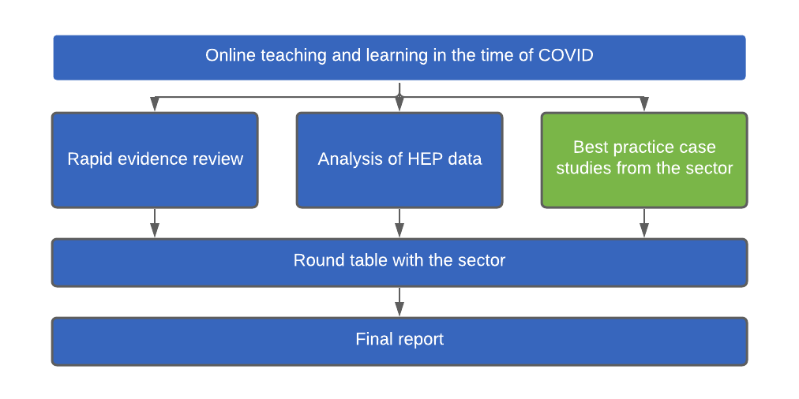
Figure 1: Online T&L project components.

Scope of the best practice submissions
We welcome examples of local evaluations that adhere to the following criteria:
- The evaluation has taken place since the start of the pandemic, March 2020, and is focussed on understanding the impact of the pandemic, and the switch to online teaching and learning, on student experience and success.
- The evaluation is focused on understanding the experience of disadvantaged learners, and learners from Black, Asian and minority ethnic groups, and how

they have been impacted by the pandemic and moving to online teaching and learning, especially when compared to their more advantaged peers.
- The evaluation focuses on how learners’ attainment and progression has been impacted.

We are also particularly interested to hear about examples that have put the student voice at the forefront of the evaluation.

TASO will be screening all submissions and selecting examples that meet the criteria outlined in the ‘screening of best practice submission’ section below. The examples that pass our screening process will be included in the project outputs - the roundtable and final report illustrated in Figure. In addition, a small sample of best practice examples will be invited to present their evaluation approach and findings at the roundtable event, due be held in summer 2021.

Timeline
Using the template below, please submit your examples of evaluation best practice using the online web form by 5pm on Friday July 9th, 2021. If you have any questions regarding the open call, please get in touch and we can arrange an informal conversation.

You will be informed of the outcome of your submission in the w/c Monday 19th July 2021.

If your submission is selected to be presented at the roundtable event, you will be invited to present in July/August - exact date to be confirmed.

Screening of best practice submissions
TASO will evaluate responses using the following criteria (in no particular order):
- The evaluation has taken place since the start of the pandemic.
- The evaluation is focussed on understanding the impact of the pandemic, and the switch to online teaching and learning, on student experience and success.
- The evaluation is focused on understanding the experience of disadvantaged learners and/or learners from Black, Asian and minority ethnic groups.
- The evaluation focuses on how learners’ attainment and progression has been impacted.
- The clarity with which findings are communicated.
- We will favour evaluations that use the Office for Students' Type 2 and Type 3 evaluation approaches.

Data Protection Notice | Evidence submitted will be used to help write a report which we plan to publish later this year. However, no higher education providers, local authorities, charities or other organisations will be identified in any publication unless we receive written permission to do so. We may also ask your permission to refer to your evidence in a repository of best practice as part of our online evidence toolkit.  Please read the Data Protection Notice for this project before submitting your evidence.
Data Protection Notice | Do you confirm that you have read and understood the Data Protection Notice?  Yes  No
Lead organisation
Contact name
Contact job role
Contact email
Contact telephone
SECTION A: Evaluation method and design
Please provide details of the methods and design you used when conducting the evaluation. Please include information about:
- The evaluation approach and methods used
- The statistical analysis conducted
- The sample size and basic demographic breakdown
[700 words max]
SECTION B: Evaluation findings
Please provide an overview of the key findings. Please cover:
- The impact on primary outcomes of interest
- The impact on disadvantaged learners
- The strength of the evidence
[500 words max]
SECTION C: Recommendations and conclusions
Please provide an overview of the key recommendations and conclusions from your evaluation.
[300 words max]

Additional guidance
- TASO reserves the right, acting reasonably, to:
  - Discontinue the open call in the absence of appropriate submissions;
  - Change the timetable for the delivery of the project, and in such circumstances TASO will notify all applicants of any change by the fastest means possible;
  - Terminate discussions with organisations which apply;
  - Not to accept submissions at all as a result of this process.
- Under no circumstances shall TASO incur any liability in respect of any of these actions.
- No publicity regarding the project will be permitted until TASO has given express written consent to the relevant communication. No statements may be made to any part of the media regarding the nature of this open call, its contents or any proposals relating to it without the prior written consent of TASO.
- TASO will not reimburse any costs incurred by organisations in connection with preparation of their submissions.
- If you are unsure of the meaning of a question or anything in this call for submissions then it is your responsibility to ask TASO to clarify in writing via email.
- TASO will aim to answer clarification questions within five (5) working days, but does not undertake to do so. TASO may also decline to answer a question if it deems the question to be inappropriate. If TASO is unable to answer a question, this will be communicated.

