TASO is inviting students to be part of a Student Advisory Panel for a new mental health project
TASO is inviting Expressions of Interest from students interested in supporting a project aiming to help Higher Education Providers to identify and make use of effective practice to support student mental health.

The role of the Student Advisory Panel is to:
- Input into the design of interviews with relevant stakeholders to explore current interventions designed to support student mental health.
- Explore whether the evidence on effective mental health practices represents their experiences in HE.
- Support the decision-making for which Higher Education Providers the research team should partner with to evaluate their mental health interventions.
- Review how user friendly the final ‘student mental health’ digital toolkit is.

There may be further opportunities, such as guiding future activity, as the project develops.

When and where?
The panel will meet 3 - 5 times over the course of the project which ends in September 2023. Meetings will be held at TASO’s office in the Evidence Quarter, Albany House, Petty France, London. We will fund reasonable travel costs, and lunch is included as part of the day.

Who?
We are looking for current students in any year of study, or students who have left higher education within the last two years. It would be valuable to have students with lived experience of mental health issues and/or of using mental health services whilst in higher education, but this is not essential. We are also looking for students who are passionate about this type of work, and/or who have studied a relevant subject, such as Psychology.

Timeline
The deadline for application is midday on Friday 19th August. You will be informed of the outcome of your submission in the w/c 29th August.

Introduction to TASO
The Centre for Transforming Access and Student Outcomes in Higher Education (TASO) aims to improve lives through evidence-based practice in higher education (HE). Our vision is to eliminate equality gaps for disadvantaged and underrepresented groups, allowing all students to have the same chance to enter HE, succeed in HE, and progress into further study or employment.
We are an independent hub for HE professionals to access research, toolkits and evaluation guidance to eliminate equality gaps. We inform practitioners of the best available evidence and produce new evidence on the most effective approaches. TASO is an affiliate ‘What Works’ centre and is part of the UK Government’s What Works Movement.

Background to mental health project
TASO has recently been appointed to lead a Consortium of five partners to help HE providers identify and make use of effective practice to support student mental health. The work will lead to the creation of a central, online hub to share what works to support student mental health.

The overarching aim for this project is to develop and promote a digital repository that provides information which the HE sector can apply to improve the efficacy of their mental health practices, including:

- A typology of mental health practices delivered in HE;
- A toolkit which sets out what works (and what does not), why, in what context and for whom in relation to student mental health;
- An evidence gap map, which will include links to evaluation guidance to help providers assess the impact of their mental health practices on longer-term outcomes such as retention, progression and attainment.
To achieve the overarching aim, the project will involve three main phases: a gap analysis; generation of evidence; and review and dissemination - as illustrated in Figure 1 below. The student panel will sit alongside the length of the project, advising and having input in relevant stages.

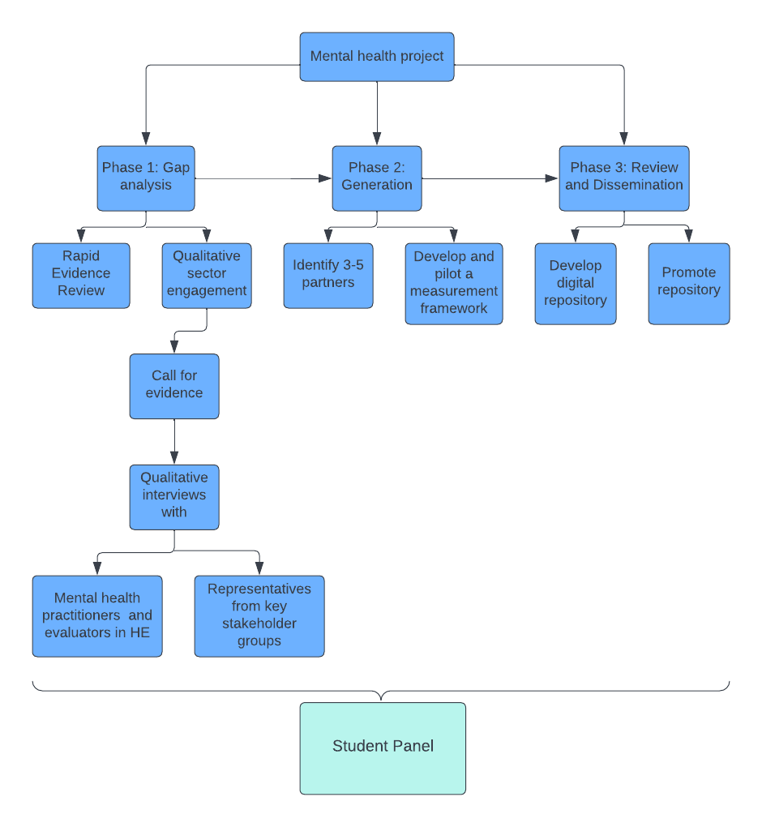

Figure 1

APPLICATION FORM

Data Protection Notice | Information submitted will be used by the project team to consider your suitability for a position on the advisory panel.  Please read the Data Privacy Notice for this project before submitting your application.  Do you confirm that you have read and understood the Data Privacy Notice:  Yes  No
Contact name
Contact email
Contact telephone

Higher Education Experience
University/Higher Education Provider
Subject
Year of study

Why are you interested in joining the mental health student advisory panel at TASO?
(eg: what knowledge, skills and experience do you bring?)
Is there any other information you’d like us to consider?
(Eg. Lived or work experience)

To apply: please email your completed application form by midday on Friday 19th August 2022 to research@taso.org.uk

Additional guidance:
- TASO reserves the right, acting reasonably, to:
  - Discontinue the invitation in the absence of appropriate submissions;
  - Change the timetable for the delivery of the project, and in such circumstances TASO will notify all applicants of any change by the fastest means possible;
  - Not to accept submissions at all as a result of this process.
- Under no circumstances shall TASO incur any liability in respect of any of these actions.

